

E-Manual

Database Systems

PROPOSED BY: Sagar Chhabriya

Database Management System is a generalised software which is used to manage database and database objects, such as tables, users, procedures, functions, etc., and to connect database with any front-end (language) with the help of some hardware.

Database Management

System

Instructor: Muhammad Faiz

2024

Table of Contents

**Chapter 1: Introduction to Database Systems**

Installation of Oracle 10g 4

Step 1: Download Oracle 10g from cloud/Shareware. 4

Database Systems 28

Data and Information 28

Database 28

Why Database? 28

Database System Applications 28

Purpose of Database 29

View of Data 29

Data Abstraction 29

Instances and Schemas 30

Data Models 30

Relational Model 30

Entity-Relationship Model 30

Object-Based Data Model 30

Semi-Structured Model 31

Database Languages 31

Data Manipulation Language 31

Data Definition Language 31

Metadata 32

Operational Data 32

Components of Database Systems 32

Database Characteristics 33

Database Management 33

DBMS Activities: 33

Database Management System 33

File Database Management System 33

Data Storage and Querying 34

Storage Manager 34

Storage Manager Components 34

Query Processor 34

Transaction Management 35

Database Architecture 36

Characteristics, Features, or Advantages of Database Systems 37

Limitations of Database 37

Data Mining and information retrieval 37

RDBMS Terminology 38

Relation Characteristics 38

Tuple and Cardinality 38

Attribute and Degree 38

Domain 38

Unary, binary, ternary, n-ary 38

Schema 39

Schema Diagram 39

Relational Query Languages 39

Relational Algebra 39

Domain 39

**Chapter 2: Relation Database Model and Relational Database Management System**

# Installation of Oracle 10g

# Step 1: Download Oracle 10g from cloud/Shareware.

**Right-click on setup and select properties.**

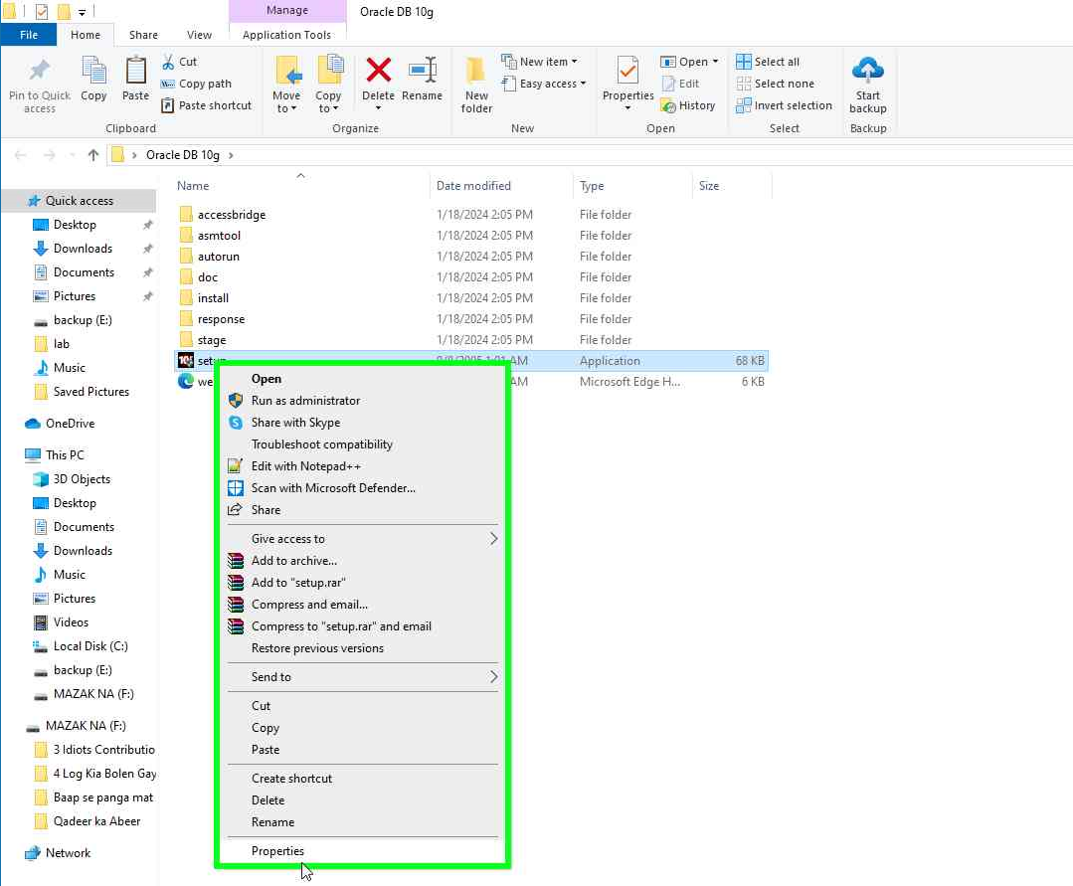**Select Compatibility**

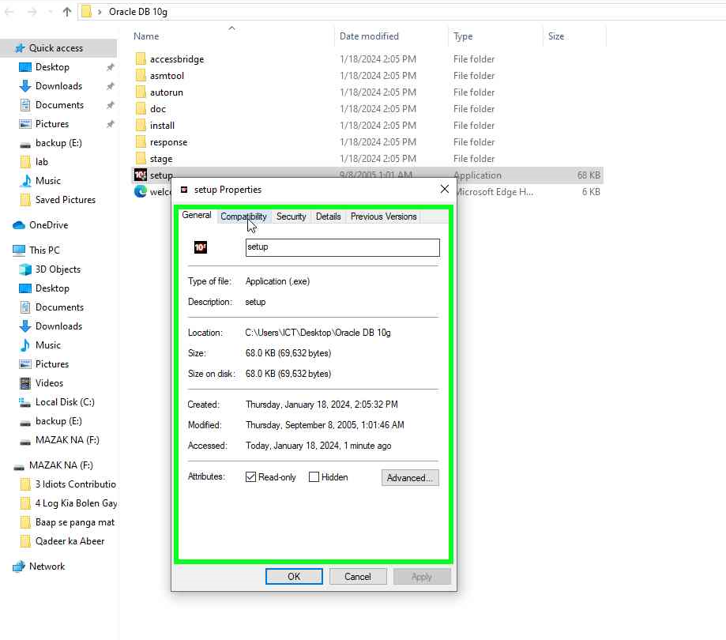

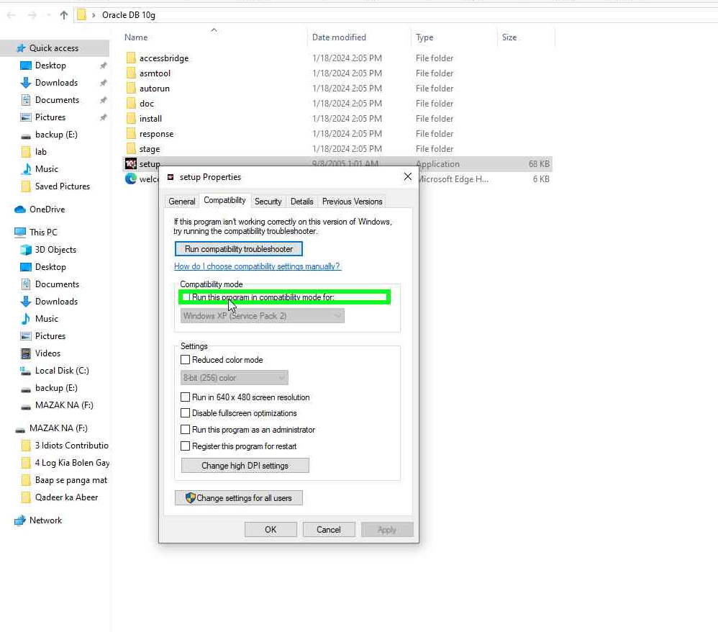**Mark the “Run this program in compatibility mode for” checked**

**Click on ”Change settings for all users” and allow.**

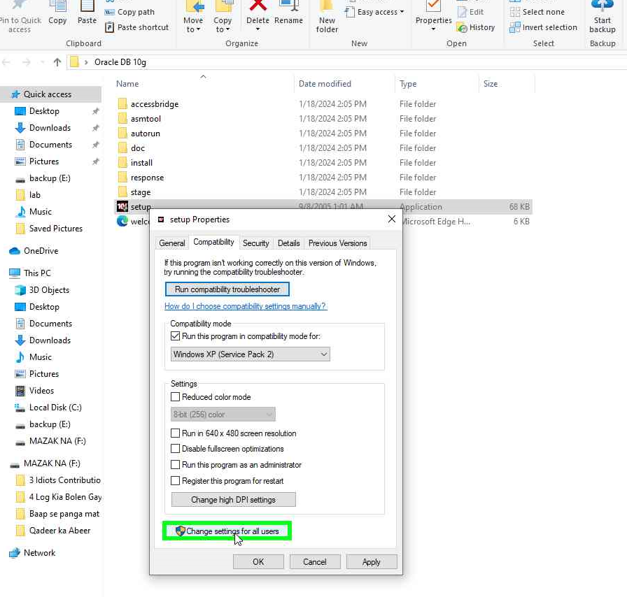

**Mark the “Run this program in compatibility mode for:” checked in the Compatibility for all users dialog box.**

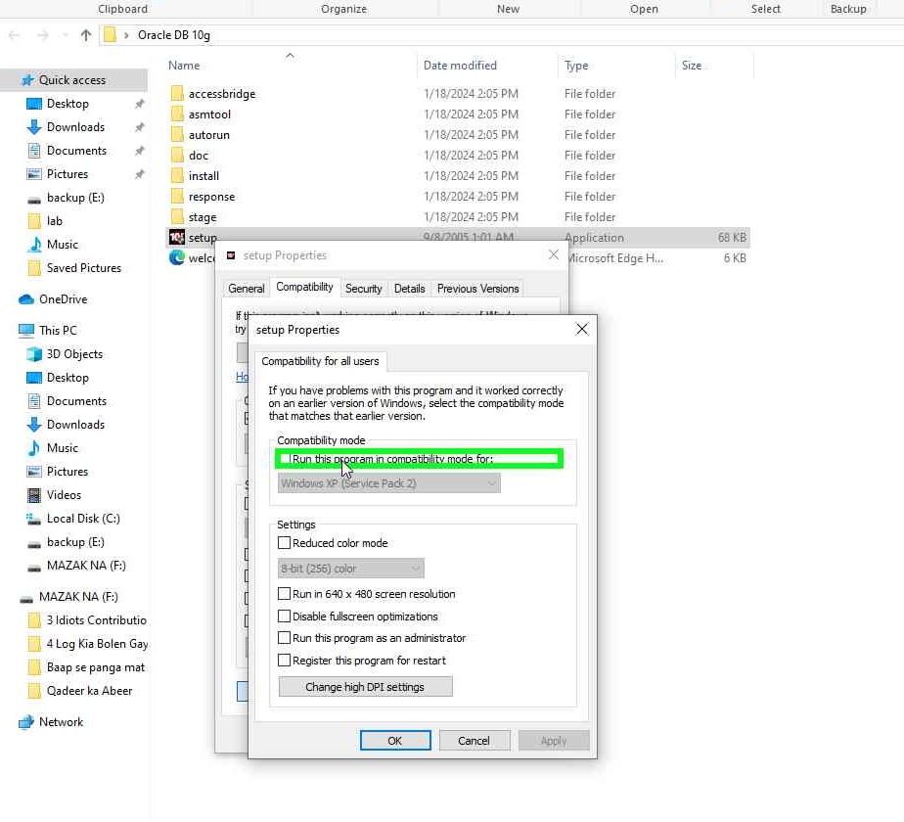

**Click “OK” in Compatibility for all users dialog box.**

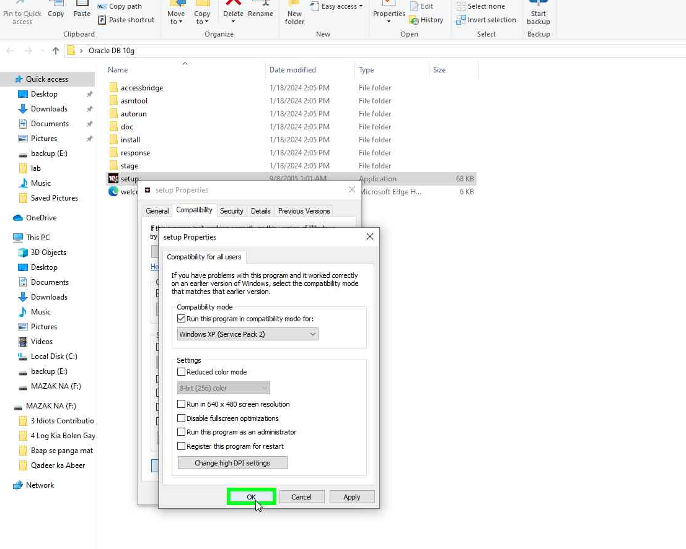

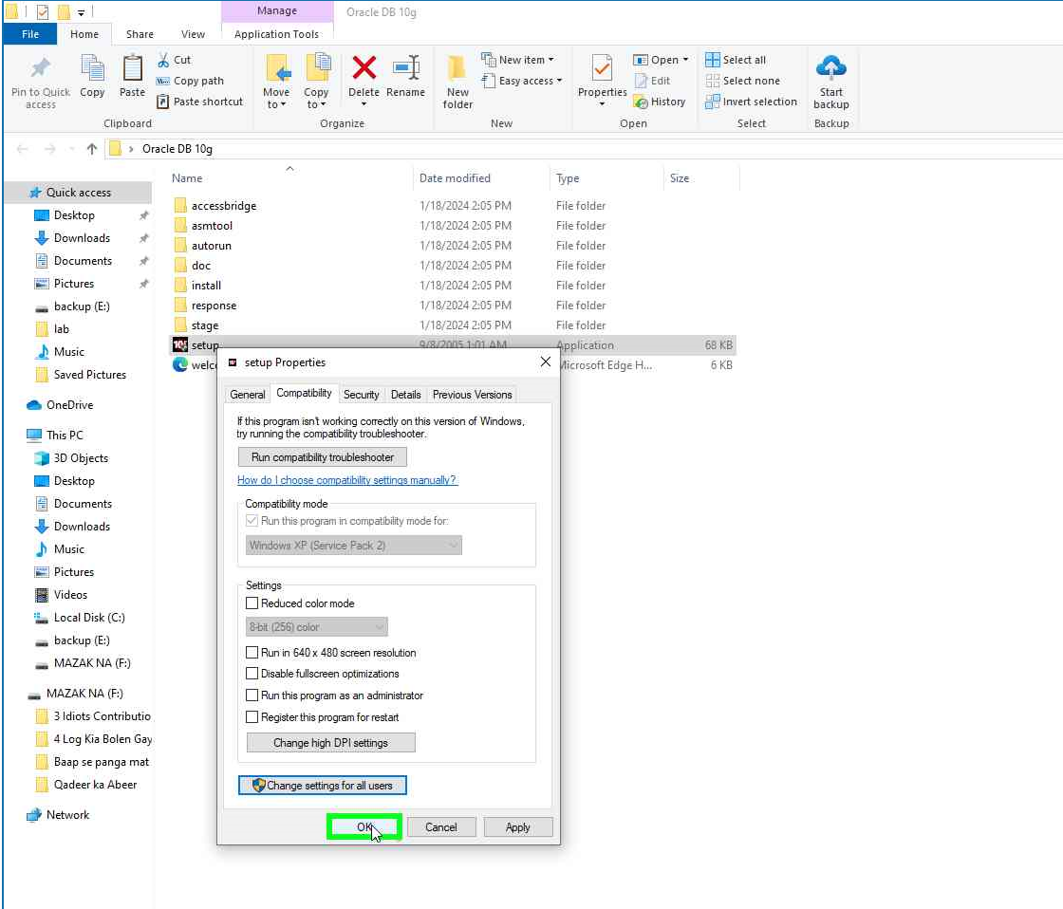**Click “OK” in the Setup Properties dialog box.**

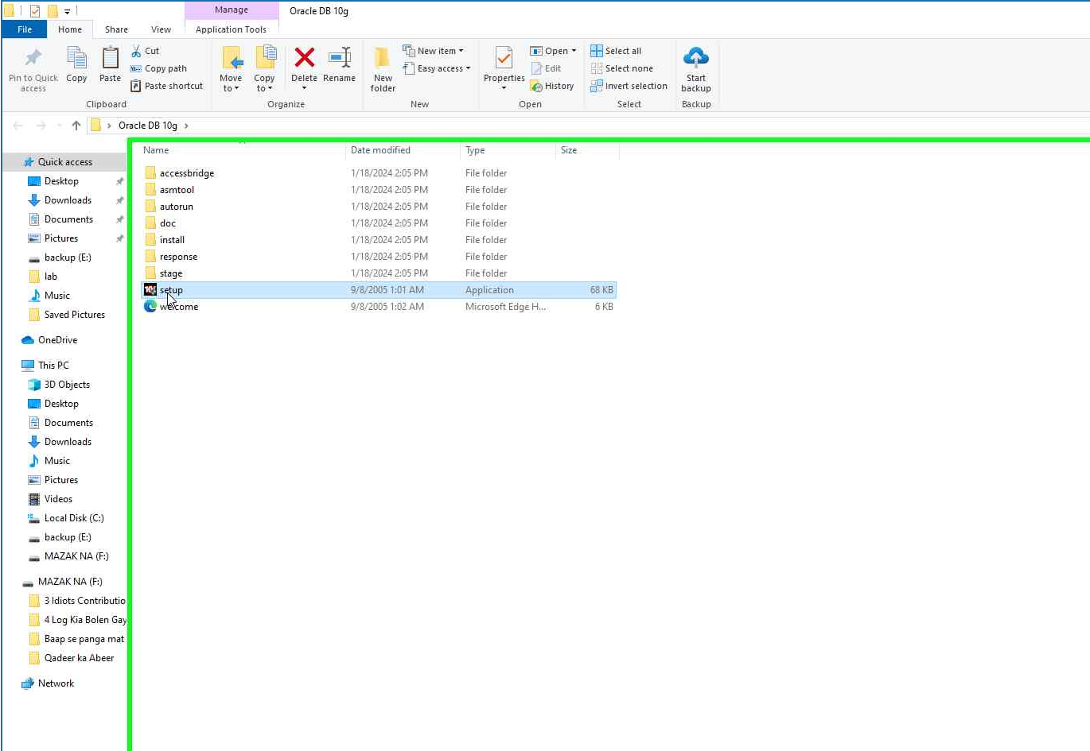**Right-click on Setup.**

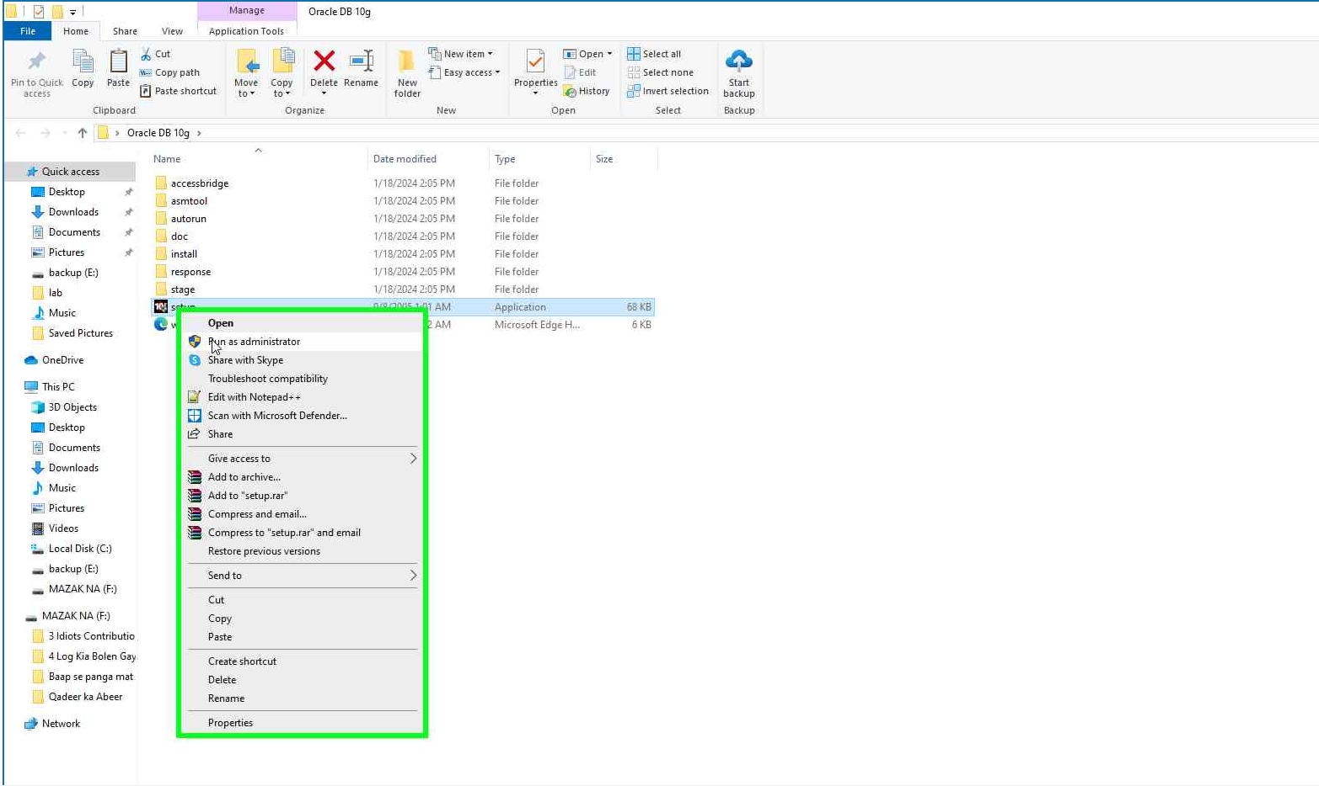**Select “Run as Administrator”**

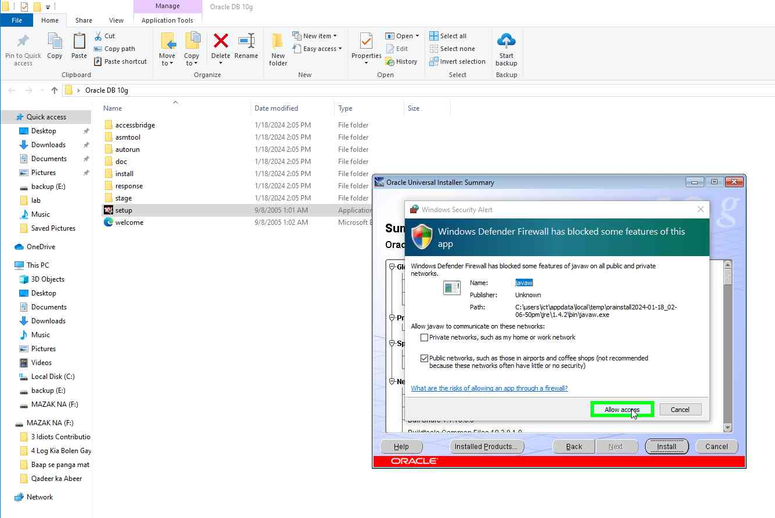**Click on “Allow Access”**

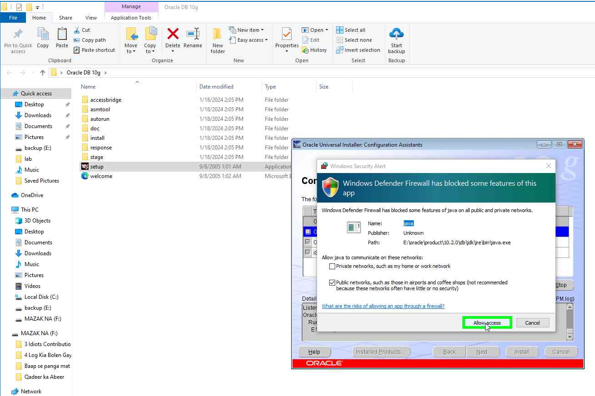

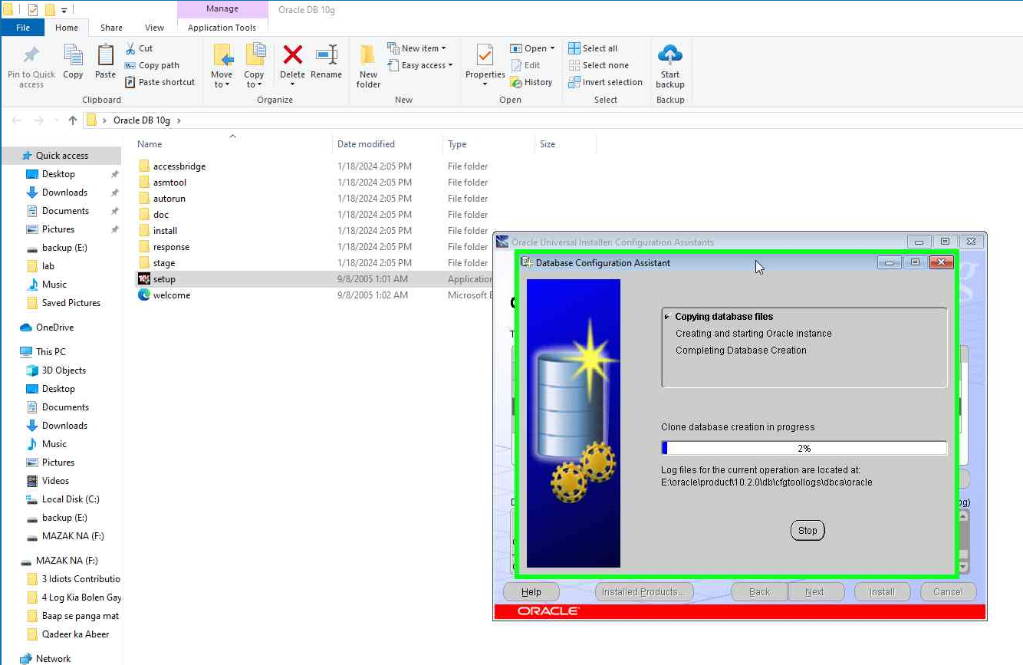

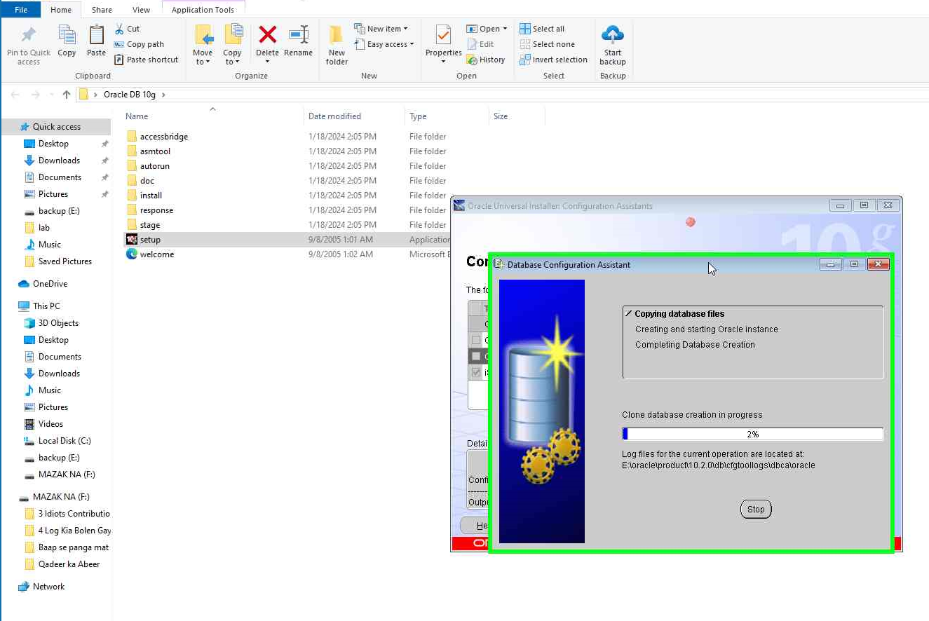

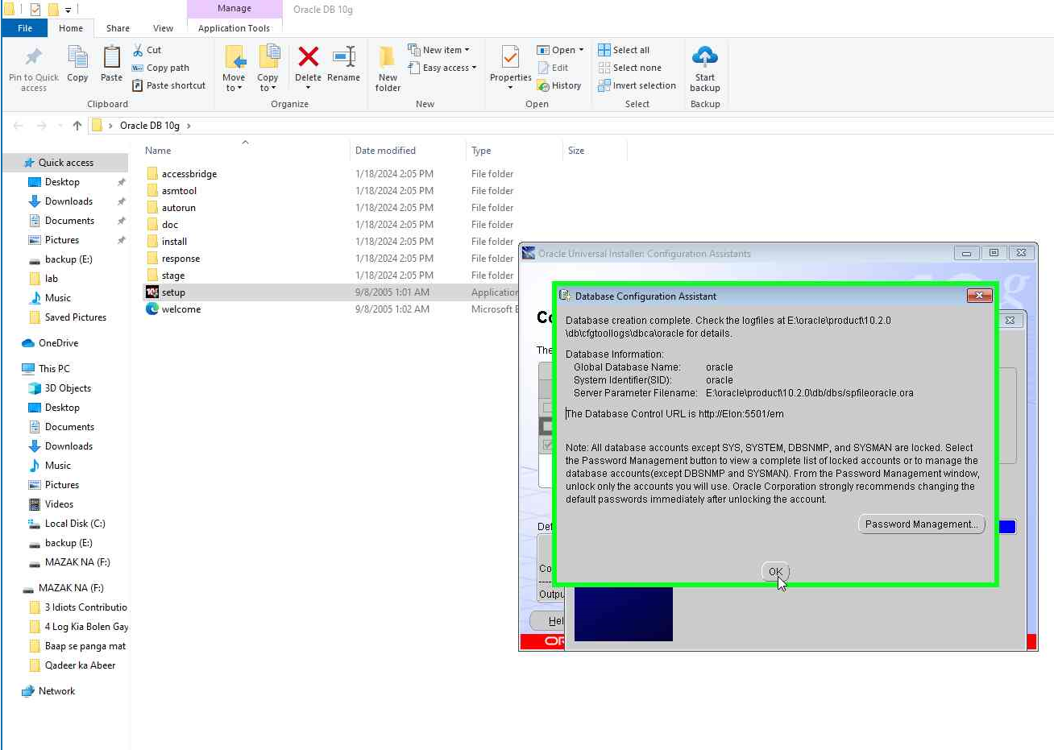

**In case, you have uninstalled the existing Oracle 10g.**

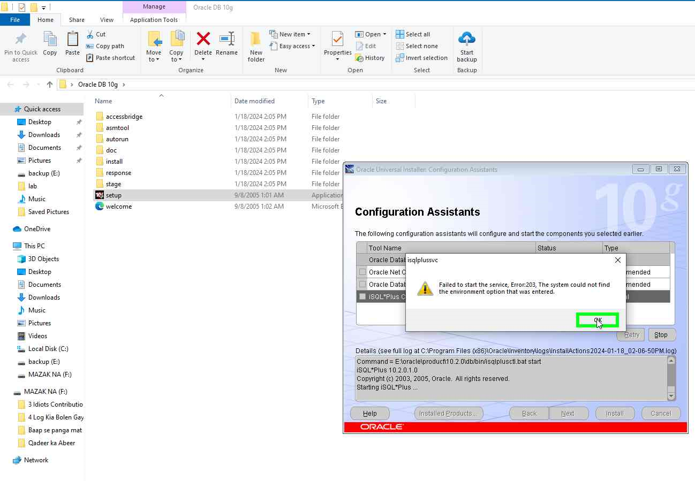

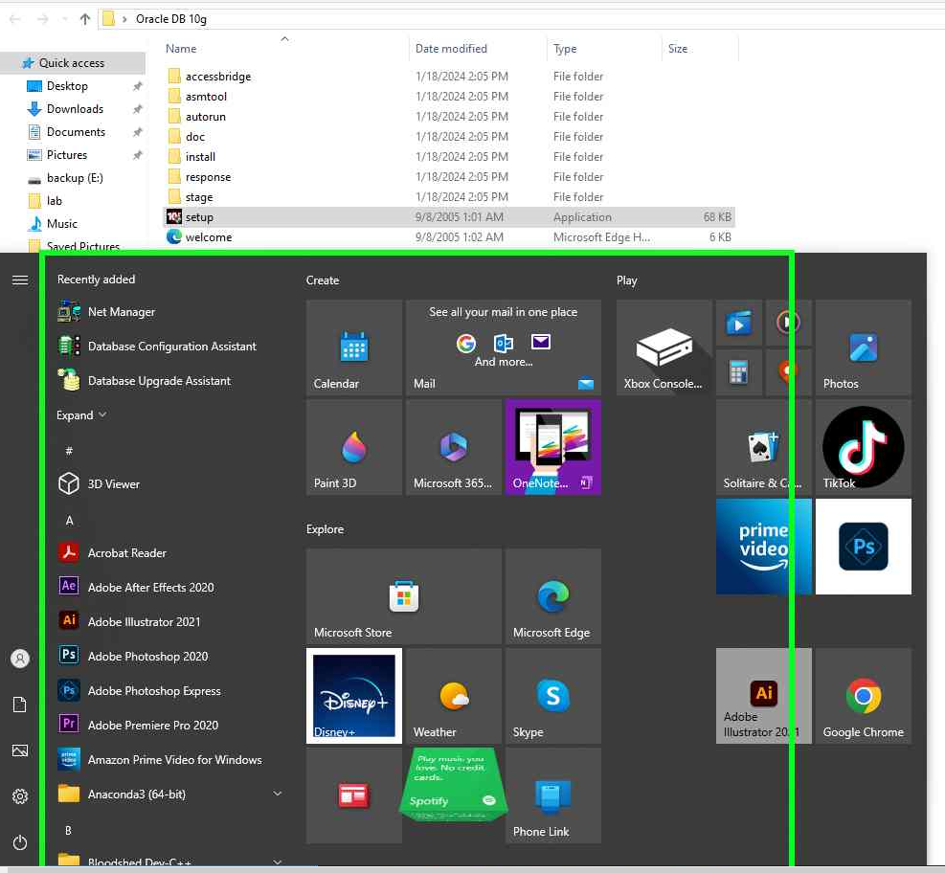

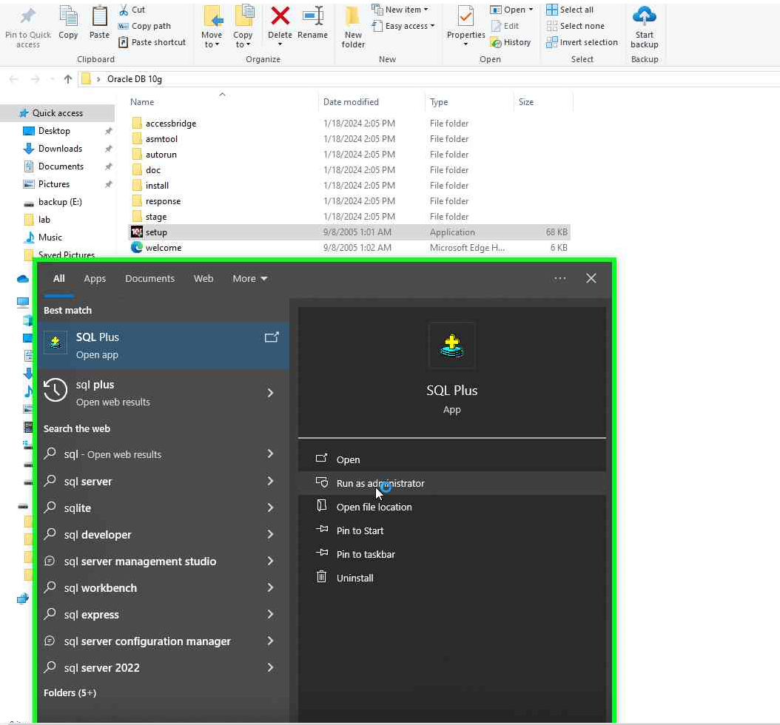

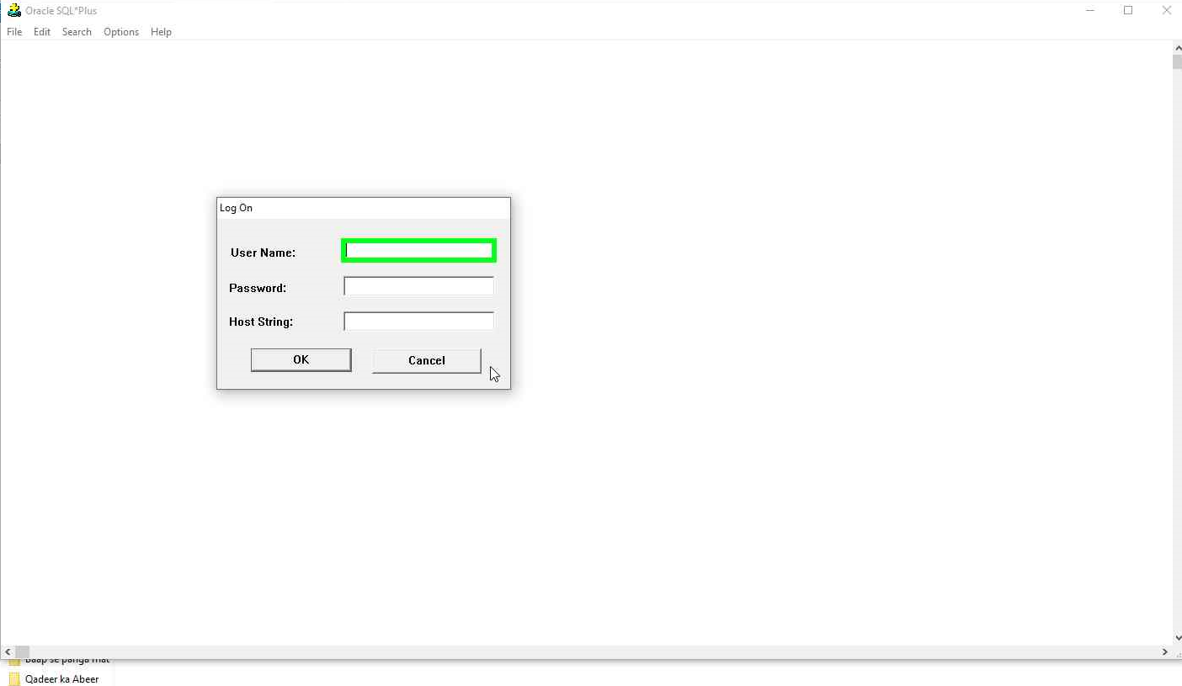

0

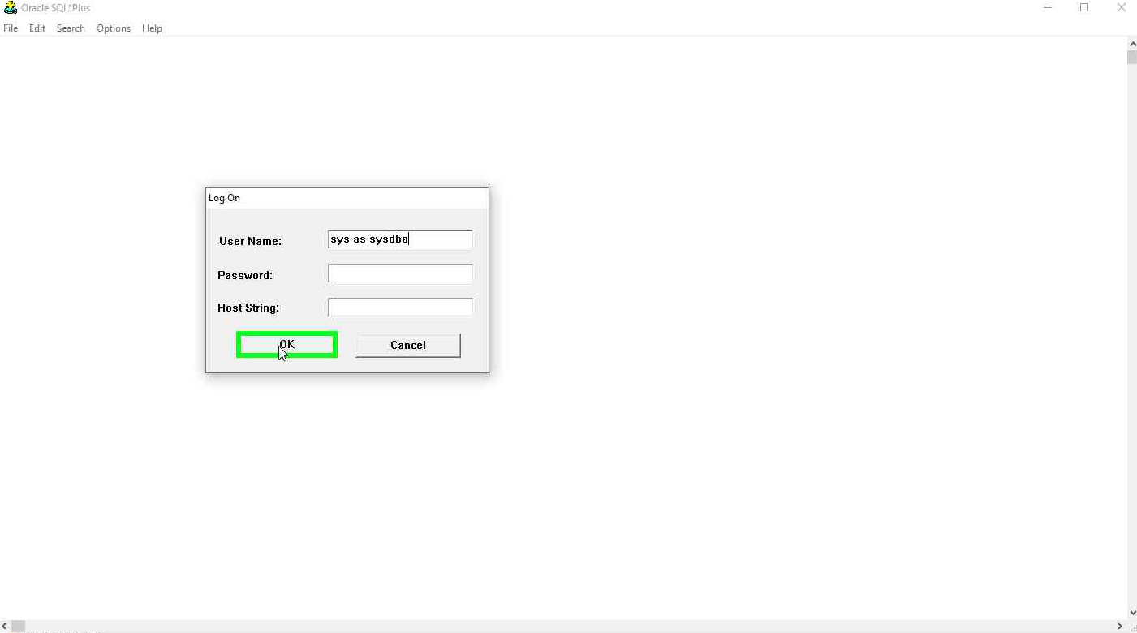

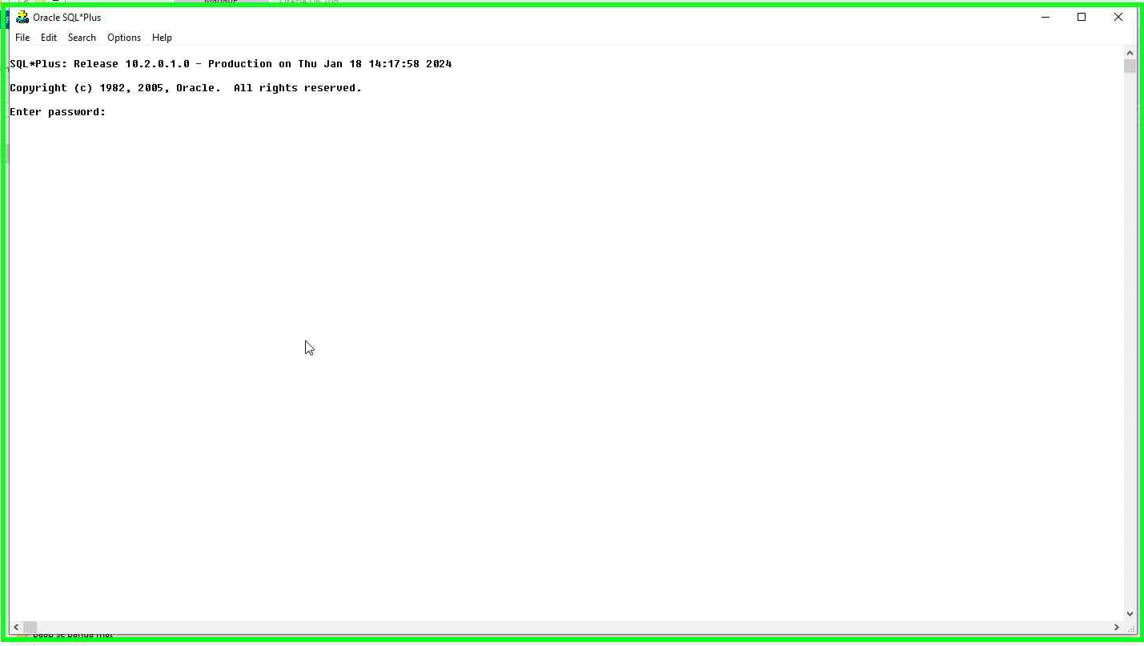

**By default, the Database Administrator Password is tiger (in lower case), or enter the password that you entered at** the time of installation.

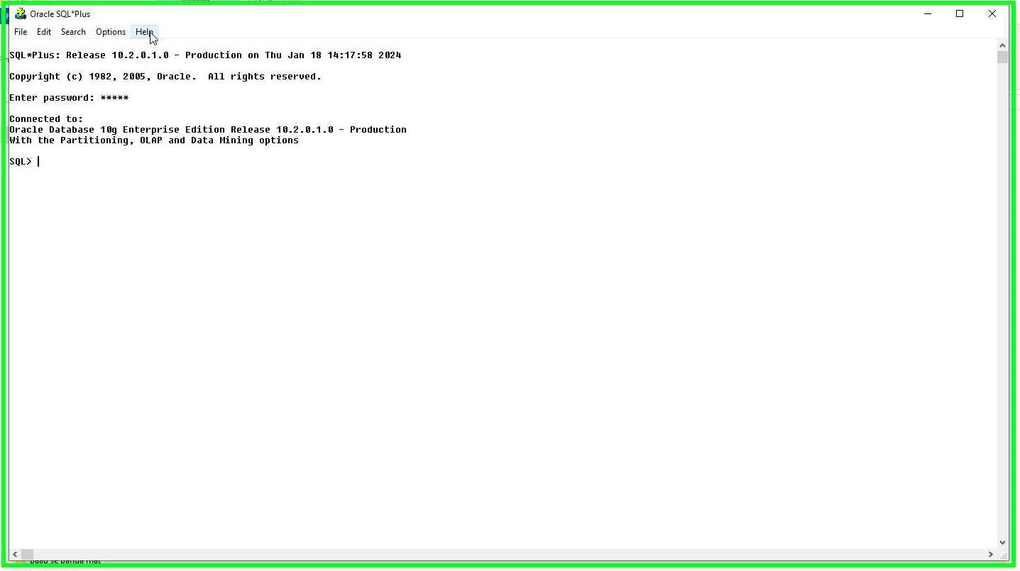

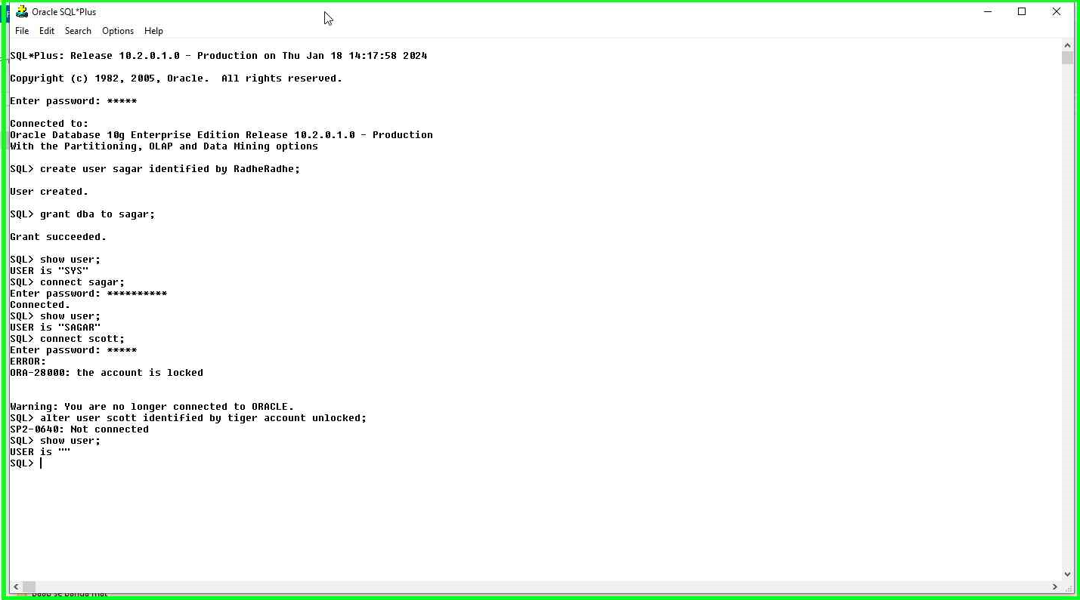

***‘Where there is a will, there is a way!’ as ‘Where there is a computer, there is a database.’***

# Database Systems

# Data and Information

Data is a plural of the word ‘datum’. Data are raw facts which may be numbers, values, names, etc. Related Data: When we combine related data, they describe any real-world entity. Related data means data that belongs to the same entity (person, place, event, or thing). When we want to describe any real-world entity, we use data values. Data values alone do not have any meaning because they are not processed yet. Information When we process related data it gives some information. Information is useful to make decisions, can be stored for future use, and has some meaning. To obtain information, we need data.

|  |  |  |
| --- | --- | --- |
| Data | Process Description | Information |
| Census Data | Sort records based on area and count the total no. of persons gender-wise and age group-wise. | Area-wise male and female ratio for different age groups. |
| Board Exam Data | Count subject-wise, no. of students who passed or failed in an exam. | Subject-wise total no. of passed or failed students. |
| Climate Data | Maximum temperature and minimum temperature during the year. | Hottest and the coldest day of the year. |

# Database

One logical database that we carry with us all the time is our brain. An example of a real-time physical database is a grain warehouse. A database is like an electronic storage, which contains computerized data files (entities). It can contain one or many data files. Data files contain various related data within it. The database should contain accurate, consistent, and non-redundant data that different application programs could share. Data can be related by defining relationships between proper data. Also, conditions (constraints) may be applied to data.

Collection of interrelated data. The **data** collection, usually called the database, contains information relevant to an enterprise. A **base** is a collection of tables and those tables have relationships.

## Why Database?

1: Database systems are designed to manage large bodies of information. 2: The database system must ensure the safety of the information stored, despite system crashes or attempts at unauthorized access.

## Database System Applications

1. Enterprise Information

For customer, product, and purchase information.

1. Banking and Finance

For customer information, accounts, loans, and banking transactions.

1. Universities

For student information, course registrations, and grades (in addition to standard enterprise information such as human resources and accounting).

1. Airlines

For reservations and schedule information. Airlines were among the first to use databases in a geographically distributed manner.

1. Telecommunication

For keeping records of calls made, generating monthly bills, maintaining balances on prepaid calling cards, and storing information about the communication networks.

## Purpose of Database

One way to keep the information on a computer is to store it in operating system files. Keeping organizational information in a file-processing system has several major disadvantages:

a) Data redundancy and inconsistency: redundancy leads to higher storage and access costs. In addition, it may lead to data inconsistency;

b) Difficulty in accessing data: Write computer programs or extract manually for the required student's names.

c) Data isolation: different types of data.

d) Integrity Problems: consistency constraints.

e) Atomicity problems: S/W or H/W Failure: Consider a program to transfer $500 from the account balance of department A to the account balance of department B. Suppose a system failure occurs during the execution of the program. In that case, it is possible that the $500 was removed from the balance of Department A but was not credited to the balance of Department B, resulting in an inconsistent database state. Atomic: atomic—it must happen in its entirety or not at all.

f) Concurrent-access anomalies: simultaneous access.

g) Security problems: Not every user of the database system should be able to access all the data.

## View of Data

1. Data Abstraction

Physical level, Logical level, view level

1. Instances and Schemas
2. Data Models

Relational Model, Entity-Relationship Model, Object-Based Data Model, and Semi-structured Data Model also: Hierarchical, Network, etc.)

## Data Abstraction

The need for efficiency has led designers to use complex data structures to represent data in the database.

* Physical Level: The lowest level of abstraction describes how the data are stored. The physical level describes complex low-level data structures in detail.
* Logical Level: describes the entire database in a small number of relatively simple structures. Database administrators use the logical level of abstraction to decide what information to keep in the database.
* View Level: The highest level of abstraction describes only part of the entire database. Many users of the database system do not need all this information; instead, they need to access only a part of the database. The view level of abstraction exists to simplify their interaction with the system. The system may provide many views for the same database.

## Instances and Schemas

Databases change over time as information is inserted and deleted. The collection of information stored in the database at a particular moment is called an instance of the database (Currently Executing Program). The overall design of the database is called the database schema. Schemas are changed infrequently, if at all. A database schema corresponds to the variable declarations (along with associated type definitions) in a program. Each variable has a particular value at a given instant. The values of the variables in a program at a point in time correspond to an instance of a database schema. Database systems have several schemas, partitioned according to the levels of abstraction. The physical schema describes the database design at the physical level, while the logical schema describes the database design at the logical level. A database may also have several schemas at the view level, sometimes called subschemas that describe different views of the database. Database → Schemas → instances. The physical schema is hidden beneath the logical schema, and can usually be changed easily without affecting application programs.

## Data Models

Underlying the structure of a database is the data model. A collection of conceptual tools for describing data, data relationships, data semantics, and consistency constraints. A data model provides a way to describe the design of a database at the physical, logical, and view levels.

The data models can be classified into four categories:

1. Relational Model
2. ER-Model
3. Object-Based Data Model, and
4. Semi-structured Data Model.

### Relational Model

The relational model uses a collection of tables to represent both data and the relationships among those data. Each table has multiple columns, and each column has a unique name. Tables are also known as relations. The relational model is an example of a record-based model. Record-based models are so named because the database is structured in fixed-format records of several types. Each table contains records of a particular type. Each record type defines a fixed number of fields or attributes. The columns of the table correspond to the attributes of the record type. The relational data model is the most widely used, and a vast majority of current database systems are based on the relational model.

### Entity-Relationship Model

The entity-relationship (E-R) data model uses a collection of basic objects, called entities, and relationships among these objects. An entity is a “thing” or “object” in the real world that is distinguishable from other objects.

### Object-Based Data Model

Object-oriented programming (especially in Java, C++, or C#) has become the dominant software development methodology. This led to the development of an object-oriented data model that can be seen as extending the E-R model with notions of encapsulation, methods (functions), and object identity. The object-relational data model combines features of the object-oriented data model and relational data model.

MongoDB does offer an OOD called Realm where the query language constructs native objects through the SDK you use. For example, in the JavaScript SDK, an object fetch looks something like const myTask = realm.objectForPrimaryKey("Task", 12345); More: <https://www.mongodb.com/databases/>

### Semi-Structured Model

The Semi-structured data model permits the specification of data where individual data items of the same type may have different sets of attributes. This is in contrast to the data models mentioned earlier, where every data item of a particular type must have the same set of attributes. The Extensible Markup Language (XML) is widely used to represent semi-structured data.

## Database Languages

A database system provides a data-definition language to specify the database schema and a data-manipulation language to express database queries and updates. In practice, the data-definition and data manipulation languages are not two separate languages; instead, they simply form parts of a single database language, such as the widely used SQL language.

### Data Manipulation Language

Enables users to access or manipulate data as organized by the appropriate data model. Types of access: Lock, Insert, Delete, Update, Merge.

Two types of DML:

1) Procedural DML: requires a user to specify what data are needed and how to get those data.

2) Non-Procedural DML (Declarative DMLs): require a user to specify what data are needed without specifying how to get those data. Declarative DMLs are usually easier to learn and use than procedural DMLs. the database system has to figure out an efficient means of accessing data. 4: A query is a statement requesting the retrieval of information. The portion of a DML that involves information retrieval is called a query language. Although technically incorrect, it is common practice to use the terms query language and data manipulation language synonymously. A DML that involves information retrieval is called a query language. Although technically incorrect, it is common practice to use the terms query language and data manipulation language synonymously.

### Data Definition Language

We specify a database schema by a set of definitions expressed by a special language called a data-definition language (DDL). The DDL is also used to specify additional properties of the data. The DDL provides facilities to specify constraints.

#### Integrity Constraint

Domain Constraint: A domain of possible values must be associated with every attribute (for example, integer types, character types, date/time types). Domain constraints are the most elementary form of integrity constraint. They are tested easily by the system whenever a new data item is entered into the database.

#### Referential Integrity

Referential Integrity: There are cases where we wish to ensure that a value that appears in one relation for a given set of attributes also appears in a certain set of attributes in another relation (referential integrity = Joining Tables/Relation??).

#### Assertions

An assertion is any condition that the database must always satisfy. Domain constraints and referential-integrity constraints are special forms of assertions.

#### Authorization

Read authorization, which allows reading, but not modification, of data; insert authorization, which allows insertion of new data, but not modification of existing data; update authorization, which allows modification, but not deletion, of data; and delete authorization, which allows deletion of data.

#### DDL Constraints with Examples

Domain Constraints: Ensuring 'age' in a database table is an integer between 0 and 120.

Referential Integrity: Matching 'Department' names in 'Course' records with existing 'Department' entries to ensure consistency.

Assertion: Verifying that 'Student ID' exists for every enrolled student in the 'Enrollment' table.

Authorization: Granting 'read' access for viewing, 'insert' for adding, 'update' for modifying, and 'delete' for removing records in a 'Customer' table, based on user roles.

## Metadata

The database management software generates a data dictionary that contains ‘data about data’ or ‘metadata’.

## Operational Data

The database contains data stored in the computer. To process the stored data, we need application programs. The processed data could be again stored in the database for future use. The data, on which we can do some processing, is known as operational data.

## Components of Database Systems

1. Users
2. Hardware
3. Software
4. Data

* Users
* Naive User, End-user, or Layman: The clerk does not know anything about the technical features.
* Software Programmer, Application Programmer, or Application Developer: A software programmer is a person who writes application programs. Query Language is a generalized language that is available with all databases.
* Database designer: A database designer decides about entities (data files) that should be stored within the database.
* Database administrator: Overall all in charge of the database.
* Hardware: For security purposes, a copy of the database could be kept on some other storage device.
* Software: (data dictionary management, database schema management, SQL)
* Data: The most important component of the DBS. Table > Records > Data Values.

## Database Characteristics

* There should be no need to create a copy of the same data.
* Integration: Integration means, changes in one data file should also be reflected in the related data file.
* Redundancy: Avoid duplication. It isn't possible to remove redundancy at all.
* The data.

## Database Management

The process of managing data within a database is called database management.

### DBMS Activities:

* Writing schema for creating new data files, updating the structure of existing data files, and deleting a data file.
* Setting relationships among data files.
* Inserting, deleting, and updating data values within data files.
* Maintaining data dictionary.
* Creating, updating, and deleting database objects other than data files, such as views, synonyms, procedures, functions, triggers, indexes, etc.

## Database Management System

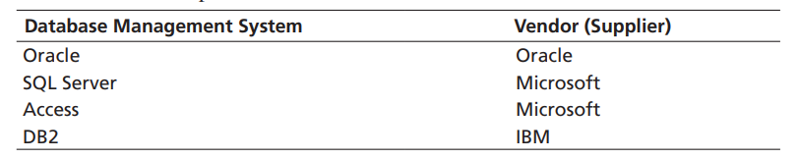Database Management System is a generalized software that is used to manage database and database objects, such as tables, users, procedures, functions, etc., and to connect the database with any front-end (language) with the help of some hardware.

#### Need for a database

Required for Efficient data storage, (CRUD). Grouping interrelated data can be Physical or Logical. Once a database is created it can be shared by many users. It is required for storing high volumes and complex data, such as documents, photographs or images, multimedia data, mobile user data, and audio and video files. For managing multidimensional data. For proper transaction handling.

## File Database Management System

File-based data management system is used by programmers to manage data. Languages, such as C or COBOL contain a file management system within it. In file-based systems, data are managed using data files, and these files are created and manipulated by writing application programs.

Disadvantages: File-based management system is not appropriate when the volume of data is very high. For example, it will be difficult to handle when daily transactions are in thousands or more numbers. When the number of data files increases, it becomes very complicated to manage data files, i.e., if the number of data files increases, the number of application programs also increases;

Examples of FDMS: CUI, dBase, and FoxPro

The database system is required to overcome the limitations of the file-based management system. The traditional database system contains data files that could be used to store data. Examples of simple database management systems are dBase and FoxPro. This DBMS contains CUI (Character-based User Interface) which provides faster access to data using commands. There is no need to create data files manually. In simple DBMS, data files with data field names and data types can be created. However, a simple DBMS does not provide the facility to define keys.

## Data Storage and Querying

Data Querying: A database system is partitioned into modules that deal with each of the responsibilities of the overall system. The functional components of a database system can be broadly divided into the storage manager and the query processor components. Queries written in a nonprocedural language, are evaluated at the logical level.

## Storage Manager

The storage manager is the component of a database system that provides the interface between the low-level data stored in the database and the application programs and queries submitted to the system. The storage manager is responsible for the interaction with the file manager. The raw data are stored on the disk using the file system provided by the operating system. The storage manager translates the various DML statements into low-level file-system command.

### Storage Manager Components

The storage manager is the component of a database system that provides the interface between the low-level data stored in the database and the application programs and queries submitted to the system. The storage manager is responsible for the interaction with the file manager. The raw data are stored on the disk using the file system provided by the operating system. The storage manager translates the various DML statements into low-level file-system commands.

* Authorization and integrity.
* Transaction Manager.
* File Manager.
* Buffer Manager.

## Query Processor

The Query processor components include:

1) DDL Interpreter: which interprets DDL statements and records the definitions in the data dictionary. 2) DML Compiler: which translates DML statements in a query language into an evaluation plan consisting of low-level instructions that the query evaluation engine understands. [A query can usually be translated into many of alternative evaluation plans that all give the same result. The DML compiler also performs query optimization; that is, it picks the lowest cost evaluation plan from among the alternatives.] 3) Query Evaluation Engine: which executes low-level instructions generated by the DML compiler.

## Transaction Management

A transaction is a collection of operations that performs a single logical function in a database application. The transaction manager consists of the concurrency-control manager and the recovery manager.

## Database Architecture

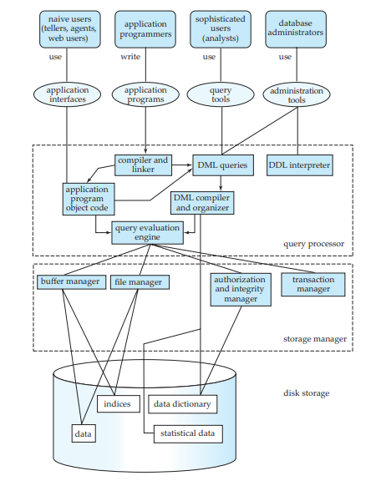

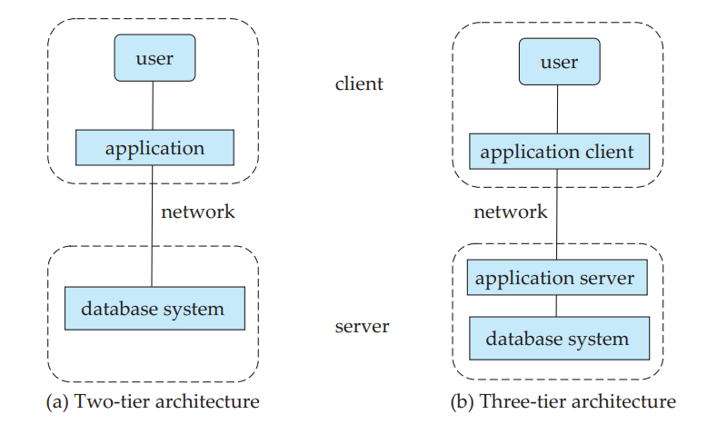

## Characteristics, Features, or Advantages of Database Systems

* Data can be shared.
* Duplication of data can be minimized.
* Handles the problem of updating when two users try to change the same data at the same time.
* The priority is decided by the DBMS software based on some algorithms.
* No need to write long programs to manage data.
* Data inconsistency can be avoided. As data are integrated.

## Limitations of Database

Nothing is 100% perfect. Advantages also bring along limitations with them. The database management system also has some limitations.

The cost of the hardware.

High-end hardware to install on the network.

Accessibility: As data can be shared through DBMS, it is difficult to control and keep track of data accessed by users. Proper encryption and decryption techniques are required to secure data over a network.

Slower: If data volume is very high, performance will be poor. Also, when too many users are using the database simultaneously, it may generate traffic on the network and slow the response time.

## Data Mining and information retrieval

The term data mining refers loosely to the process of semi-automatically analyzing large databases to find useful patterns. **Like knowledge discovery in artificial intelligence (also called machine learning) or statistical analysis, data mining attempts to discover rules and patterns from data**. However, data mining differs from machine learning and statistics in that it deals with large volumes of data, stored primarily on disk. That is, data mining deals with “**knowledge discovery in databases.**”

Chapter 2

Relational Database Model and Relational Database Management System

The relational data model is based on a collection of tables. The user of the database system may query these tables, insert new tuples, delete tuples, and update (modify) tuples. There are several languages for expressing these operations.

## RDBMS Terminology

The relational data model is based on relations and relationships between these relations. The relation is a combination of related entity occurrences. The entity is a collection of related entity occurrences.

### Relation Characteristics

1. Each row represents one tuple of a relation (table). 2. The ordering of rows is not important in a relation. 3. All tuples should be distinct (unique). This can be achieved by defining a unique identifier for each tuple. 4. The ordering of columns is significant because it corresponds to the ordering of the domains on which the Relation is defined. 6. Relation is a two-dimensional structure that is made up of tuples and attributes. 7. The intersection of a tuple and an attribute should contain a single value.

### Tuple and Cardinality

Each entity occurrence represents one object. An entity occurrence is represented as a tuple in the relation. The total number of tuples in a relation is known as the cardinality of that relation.

### Attribute and Degree

Each entity occurrence has some attributes. Attributes describe the object, i.e., an attribute is a characteristic of the object. All attributes together tell about the object. The total number of attributes in a relation is known as the degree of the relation.

### Domain

The values of attributes are derived from some valid set of predefined values, which is known as the Domain of an attribute. Two attributes may have the same domain within the relation.

Example:

There are 10 tuples in the relation STUDENT. Therefore, the cardinality of this relation is 10. There are a total of seven attributes in the relation STUDENT. So, degree of this relation is seven, i.e., it is a seven-ary relation.

### Unary, binary, ternary, n-ary

The relation which has only one attribute is known as unary relation, relation with two attributes is known as binary relation, relation with three attributes is known as ternary relation… and relation with n attributes is known as n-ary relation.

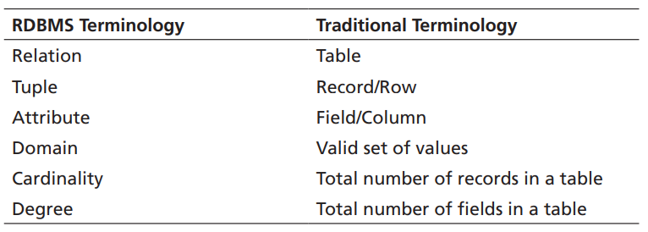

## Schema

The schema of a relation refers to its logical design, while an instance of the relation refers to its contents at a point in time. The schema of a database and an instance of a database are similarly defined. The schema of a relation includes its attributes, and optionally the types of the attributes and constraints on the relation such as primary and foreign key constraints.

## Schema Diagram

A schema diagram is a pictorial depiction of the schema of a database that shows the relations in the database, their attributes, and primary keys and foreign keys.

## Relational Query Languages

The relational query languages define a set of operations that operate on tables, and output tables as their results. These operations can be combined to get expressions that express desired queries.

### Relational Algebra

Relational algebra provides a set of operations that take one or more relations as input and return a relation as an output. Practical query languages such as SQL are based on relational algebra but add several useful syntactic features.

### Domain

For each attribute of a relation, there is a set of permitted values, called the domain of that attribute.

#### Atomic Domain (Elementary Data Item)

A domain is atomic if elements of the domain are considered to be indivisible units.

#### Non-Atomic Domain (Group Data item)

The important issue is not what the domain itself is, but rather how we use domain elements in our database. Suppose now that the phone number attribute stores a single phone number. Even then, if we split the value from the phone number attribute into a country code, an area code, and a local number, we would be treating it as a non-atomic value. Stored data is processed with the help of database management systems.

Class Code Work:

# Commit and Rollback

* Rollback: When we add wrong records in some table and want to undo we use the rollback command.
* Commit: When we use the Commit command then the used commands change into permanent. Likes as saving operation.

Note: it is important to commit after operations because if we roll back then all operations will be erased.

Referential Integrity:

Term used in Database to define the relationship between 2 tables. Master Table & Child Table.

FD: Functional Dependency is defined as relation between the attributes (columns) in table.

X 🡪 Y:

Y is a subset of X

X is Determined to Y

Y is Dependent on X

### 2 Types

* Trivial: X -> Y & y is dependent and subset of x
* Non-Trivial: X -> Y & y is not dependent and subset of x

7 Rules of Arm`s Strong

Primary Rules

1. Reflexivity: If x -> x Call Itself, Empno 🡪 Empno (Trivial)
2. Augmentation: x -> y then xz -> yz
3. Transitivity: If x -> y & y -> z then x -> z ( CMS -> name, name -> sal then CMS -> sal )

Secondary

1. Union: if x -> z, y -> z then xy -> z

Or x -> y, x -> z then x -> yz

1. Decomposition: if x -> yz then x -> y , x -> z
2. Pseudo Transitivity: If x -> y & yA -> zA then x -> (A means any column)
3. Composition: If x -> y and A -> B then xA -> yB

Partial Dependency: If a column is only dependent on 1 Column (Primary key column) then it creates Partial Dependency. For instance, if "Course" depends on "Course_ID" and “Student” depends on “Student_ID”, and those attributes are not fully functional, then there would be a partial dependency.

To resolve this partial dependency and achieve 2NF, you would need to separate the "Course " attribute into a separate table where "Course_ID" is the primary key and "Student" is fully dependent on "Student_ID" alone.

Split that table into 2 tables.

Normalization: A process of reducing redundancy from DBMS. Normalization involves breaking down large tables into smaller, more manageable tables.

For ex: don’t make 1 table and do all the work in one table, make separate tables for separate data.

This improves data integrity and simplifies database management.

NF1: Repeating value or group not allowed.

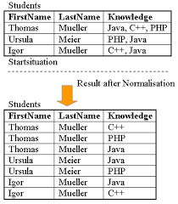

NF2: Partial Dependency is not allowed. (remove if it exists)

* Partial Dependency: Split that 1 table into 2 tables.

NF3: To Manage Transitive

A -> B, B -> C after remove transitivity A -> B & C Both

*Non-key attributes do not depend on other non-key attributes, these depend on Key attributes.*

Half NF4: We can`t make 2 primary keys in 1 table. If we want 2 primary keys in 1 table then we create a super key in table. (Collect 2 Primary keys and make 1 super key)

Full NF4: Remove multi-value dependency. (Remove Irrelevant columns/Data like as Hobby & Weight in below).

* CMS, Name, City, Hobby, Weight

NF5: Join Dependency is allowed:

# Key Attribute

A field that uniquely identifies a record in a table.

Keys are essential for maintaining the integrity and efficiency of a database.

* Super Key: (Superset), Set of 1 or more columns that identify records in a table.

Give 1,2 or 3 input & get all information, because all keys all relational.

(ABC) -> D

(AB) -> CD

1. -> BCD

SELECT D FROM example_table WHERE A=4 AND B=5 AND C=6;

* Candidate key:
  + Candidate key is only 1, but Super and Foreign key can be more than 1.
  + Candidate key is converted into Primary Key.
* Primary Key: A Primary key is a unique identifier for a record in a table, it must have a unique value for record in table and cannot be null. A Table can have only one primary key.
* Foreign Key: Create Relation B/W 2 Tables (Relation of CMS from 1st table to Relation of CMS to 2nd table but both have same size & type). It Established a relation between the two tables.
* Composite Key: A Composite Key is the combination of 2 columns that uniquely identifies record in a table.

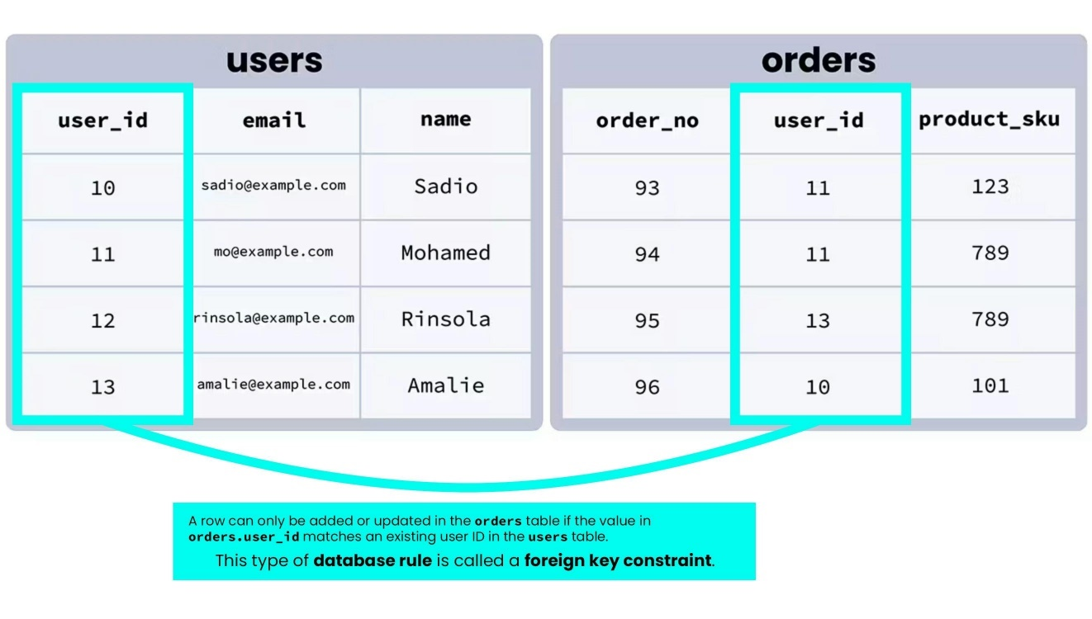

Index: An index in a database is a data structure that improves the speed of data retrieval by allowing the database to quickly find rows based on the values of certain columns. It acts like a table of contents for a book, making it faster to locate specific information. (Like Hashing)

Join: Joins are used when you need to retrieve data from multiple tables, Output will be intersection of A table and B table;

* Inner Join: Return only matching rows from both tables
  + Equal Join
    - SQL > select A.Name, city A.CMS from cs_4 A, friends B where

A.Name= B.Name;

* + - SQL > select CMS, A.Name, A.City, Job from cs_4 A, friends B where A.Name=B.Name
* Outer Join
  + Left Outer Join: Return All rows from left table and matching from right table. output data of U-B
    - SQL > select name, city, A.CMS from cs_4 A, friends B where A CMS(+) = B.CMS;
  + Right Outer Join: Return All rows from right table and matching rows from left table. output data of U-A
    - SQL > select name, city, A.CMS from cs_4 A, friends B where A CMS = B.CMS(+);
  + Full Outer Join: Return all rows from both table; output data of U
    - SQL > select name, city, A.CMS from cs_4 A, friends B where A CMS(+) = B.CMS(+);

DUAL: The DUAL table is a special one-row, one-column table present by default in Oracle databases. It's often used in SQL queries where you need to select a constant value, calculate expressions, or execute functions without querying a real table.

Commands:

1. Create a new user:

create user "username" identified by "password";

1. Drop the user:

drop user username;

1. Alter any user:

alter user "username" identified by "password";

1. Print the name of all users:

select * from dba_users;

1. Unlock existing user

alter user "username" identified by "password" account unlock;

1. To clear screen

clear screen or cle scr

1. Connect to dba account

connect "Username"

ex: connect scott

1. Clear buffer

clear buffer

1. Date

select sysdate from emp

1. Display data and time:

select sysdate from dual

Built-in tables in Scott account:

emp, depth, dual

1. Select all records from the table:

select * from tab;

1. Display the structure of the desired table

describe desiredTableName or desc desiredTableName

1. Open default editor:

editor or just type ed

1. Execute the query of buffer:

Write / or ‘run’ and press enter key.

1. Fetch defined columns:

select col1Name,col2Name,col3Name from "TableName"

1. Implicit Alias without using as keyword in oracle:

select empno 'Your Customize TBName' from emp;

1. Relational Operator:

Select empname from emp where sal > 2000;

1. Select records sorted in ascending order:

select ename from emp order by ename;

1. Sort records in descending roder:

select ename from emp order by ename desc;

1. Save buffer file:

save "Filename"

1. Load buffer information of a file:

@ "Filename"

Aggregating Functions:

sum (), count(), max(), min()

1. Second most highest salary:

select max(sal) from emp where sal!=(select max(sal) from emp);

1. Aggreagting function with group by clause:

select max(sal) from emp group by ename;

1. Select maximum data of a record from a column:

select max(sal) from emp group by ename having empno=7499;

1. Count number of rows in a table:

select count(*) from emp;

1. Select unique department:

select DISTINCT deptno,sum(sal) from emp group by deptno;

1. Multiple OR conditions:

select * from emp where sal in(1600,2000,5000);

1. Multiple AND conditions:

select * from emp where sal between 2000 and 3000;

Pattern Matching

1. Names starts with 'A':

select * from emp where ename like 'A%';

1. Names ends with the character 'N':

select * from emp where ename like '%N';

1. Names having character 'N' on any position:

select * from emp where ename like '%N%';

Creating Tables

1. create a Table:

create table table_name( id number(10) primary key, name varchar2(15), sal number(12,2))

1. Alter Table add() column:

alter table table_name add ( column_name datatype);

1. Modify Table add(primary key) column:

alter table table_name add ( primary key (column_name));

1. Change data type or size of a column:

alter table table_name modify (column_name varchar2(25) );

1. Drop Column:

alter table table_name drop column column_name;

1. Drop Table:

Drop Table_name

1. Insert data into the table:

insert into teachers (TID, Tname, Tsal) values(1, 'Younis', 999999);

1. Undo previous action:

Rollback

1. Save actions of staging area:

Commit

1. Insert data into the table repeatedly:

insert into teachers (TID, Tname, Tsal) values(&TID, '&Tname', &Tsal);

1. Update data of the table:

update emp set column_name=value where row/id = value

1. Delete a row from table:

delete from emp where empno=7654

1. Delete table:

drop table

1. Clear table data:

truncate table table_name

view ( to save complicated query) and synonym (nickname of the table for hiding the original table name)

1. Create view:

create view view_name as select deptno, max(sal) from emp group by deptno;

1. Drop view:

drop view view_name

1. Create synonym of a table hide original name of table:

create synonym synonym_name for emp;

1. Drop synonym:

drop synonym synonym_name;

PLSQL (Procedural): Indirect Mode also known as programming mode. PL/SQL is Oracle's procedural language extension for SQL, used for writing write procedural code, such as loops, conditionals, and functions, within SQL statements.

SQL > Begin

End;

Declare variables:

SQL >Declare name varchar(),

Begin

End;

*Set Output for Screen;*

*SQL > SET SERVEROUTPUT ON;*

PL/SQL: indirect mode of sql, block coding,

Command is not executed when it is written

1. For loop:

begin

for a in 1..10 loop

dbms_output.put_line(a);

end loop;

end;

/

1. Find odd and even:

begin

for a in 1..10

loop

if ( mod(a,2) = 0)

then

dbms_output.put_line( a || ' is even number');

end if;

end loop;

end;

/

1. Simple print statements:

begin

dbms_output.put_line('Name: Sagar Chhabriya’);

dbms_output.put_line('Father Name: Mukesh Kumar’);

dbms_output.put_line('City: Kandhkot');

end;

/

Name: Sagar Chhabriya

Father Name: Mukesh Kumar

City: Kandhkot

PL/SQL procedure successfully completed.

1. Explicit Cursor

declare

mno number(10);

mname emp.ename%type;

msal emp.sal%type;

cursor abc is

select empno, ename, sal from emp

order by sal desc;

begin

open abc;

while true

loop

fetch abc into mno,mnam,msal;

exit when abc%notfound;

dbms_output.put_line(mno || ' ' || mname || ' ' || msal);

end loop

close abc;

end;

1. Type operator:

declare

uid main.id%type;

uname main.name%type;

cursor abc is

select id, name from main order by id desc;

begin

open abc;

while true loop

fetch abc into uid, uname;

exit when rownum>5

dbms_output.put_line(uid || ' ' || uname);

end loop;

close abc;

end;

/

1. Else with loop:

declare

i number(3);

begin

i := 1;

dbms_output.put_line('Finding Even and odd');

loop

if mod(i,2) = 0 then

dbms_output.put_line('Even : ' || i);

else

dbms_output.put_line('Odd : ' || i);

end if;

i := i + 1;

exit when i = 100;

end loop;

end;

/

SQL> declare

sal emp.sal%Type;

cursor empcur is

select sal from emp order by sal desc;

begin

open empcur;

loop

fetch empcur into sal;

exit when empcur%rowcount = 6;

dbms_output.put_line('Sal : ' || sal);

end loop;

close empcur;

end;

/

SQL> /

Sal : 5000

Sal : 3000

Sal : 3000

Sal : 2975

Sal : 2850

-----------------Procedures March 20 ---------------------

create or replace procedure proc1

is

begin

dbms_output.put_line('ok procedure');

end;

SQL> /

Procedure created.

SQL> execute proc1

ok procedure

PL/SQL procedure successfully completed.

1. Drop Procedure:

SQL> drop procedure proc1;

Procedure dropped.

create or replace procedure sum1(x in number, y in number)

is

--declare section

z number;

begin

z := x + y;

dbms_output.put_line('The answer is ' || z);

end;

/

SQL> begin

sum1(2,3);

end;

/

The answer is 5

PL/SQL procedure successfully completed.

--------------error-----------------

create or replace function func1( x in number, y in number)

return number;

is

z number;

begin

z := x + y;

return z;

end;

/

Warning: Function created with compilation errors.

SQL> ed

Wrote file afiedt.buf

1 create or replace function func1 ( x in number, y in number)

2 return number

3 is

4 z number;

5 begin

6 z := x + y;

7 return z;

8* end;

SQL> /

Function created.

--

SQL> declare

2 x number;

3 begin

4 x := func1( 2,3);

5 dbms_output.put_line(x);

6 end;

7 /

5

PL/SQL procedure successfully completed.

--------Triggers------------

SQL> ed

Wrote file afiedt.buf

1 create or replace trigger trig1

2 before insert or delete or update on emp

3 for each row

4 begin

5 dbms_output.put_line('Someone is accessing the emp table');

6* end;

SQL> /

Trigger created.

SQL> set serveroutput on

SQL> update emp

2 set sal = 800

3 where empno = 7369;

Some is accessing emp table

1 row updated.

SQL> create table log

2 (

3 logid number(5),

4 logname varchar(35));

Table created.

SQL> create or replace trigger trig1

2 before insert or update or delete on emp

3 for each row

4 begin

5 insert into log values(1,'Someone accessed the emp table');

6 end;

7 /

Trigger created.

------------------------------------------Exception-----------------------------------------

SQL> declare

2 mc emp.empno%type;

3 mn emp.ename%type;

4 ms emp.sal%type;

5 begin

6 select &tc into mc from dual;

7 select empno, ename, sal into mc, mn, ms from emp

8 where empno=mc;

9 dbms_output.put_line(mc || mn || ms);

10 exception

11 when no_data_found then

12 dbms_output.put_line('Record not found');

13 end;

14 /

Enter value for tc: 7788

old 6: select &tc into mc from dual;

new 6: select 7788 into mc from dual;

PL/SQL procedure successfully completed.

SQL> set serveroutput on

SQL> /

Enter value for tc: 7788

old 6: select &tc into mc from dual;

new 6: select 7788 into mc from dual;

7788SCOTT1200

PL/SQL procedure successfully completed.

SQL> ALTER TABLE MEMBER MODIFY(MEMBER_ID CONSTRAINT PK PRIMARY KEY);

Table altered.

**Note: This is not my completed Manual. This will get updated in the future if I get time.**